GPS Test
time it takes to lock in: 1:15
scenario, 3rd floor under the roof (yero)
results: 14.552811, 121.062247
laptop gps (google maps)14.552845, 121.061996
phone gps: 14.552917, 121.062278
Impression: GPS data can be slightly off when there is obstruction in the sky. It can detect 12 satellites but it produces slightly off result.
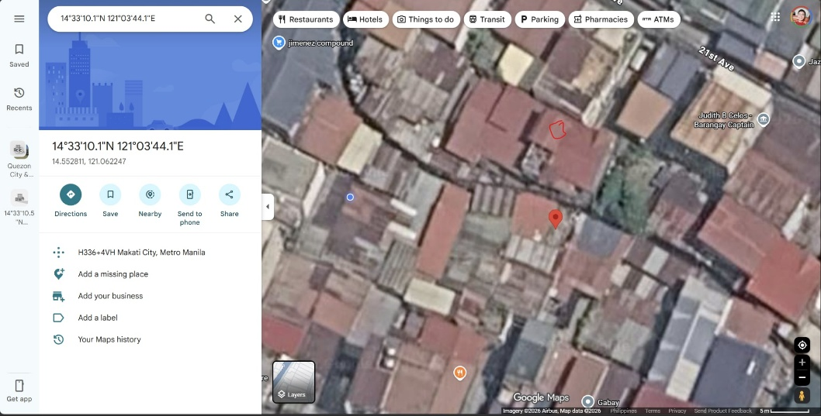
The tagged location of the GPS is around 10 to 15 meters away.
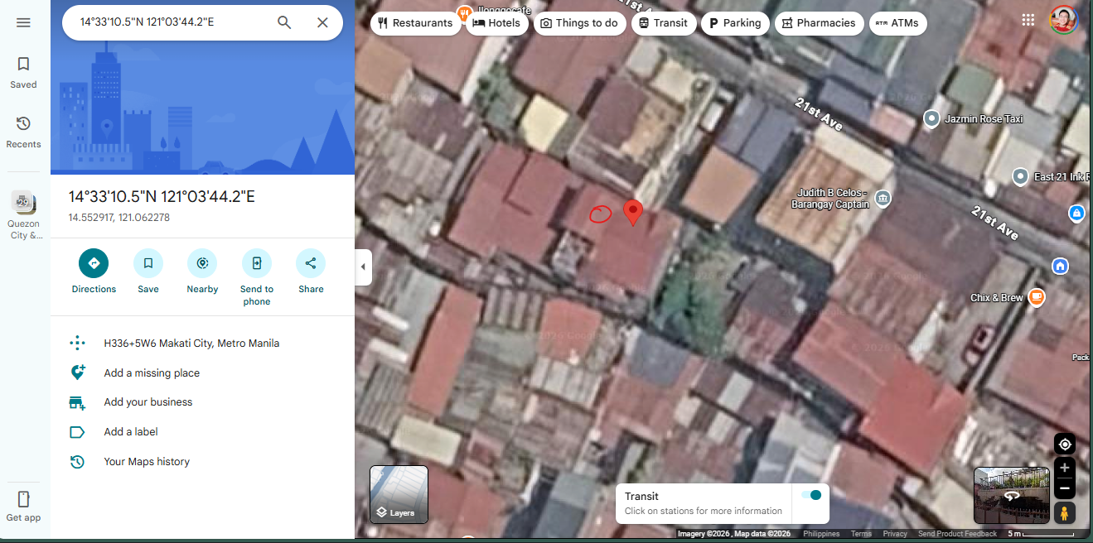
Phone GPS

At the edge of the roof:
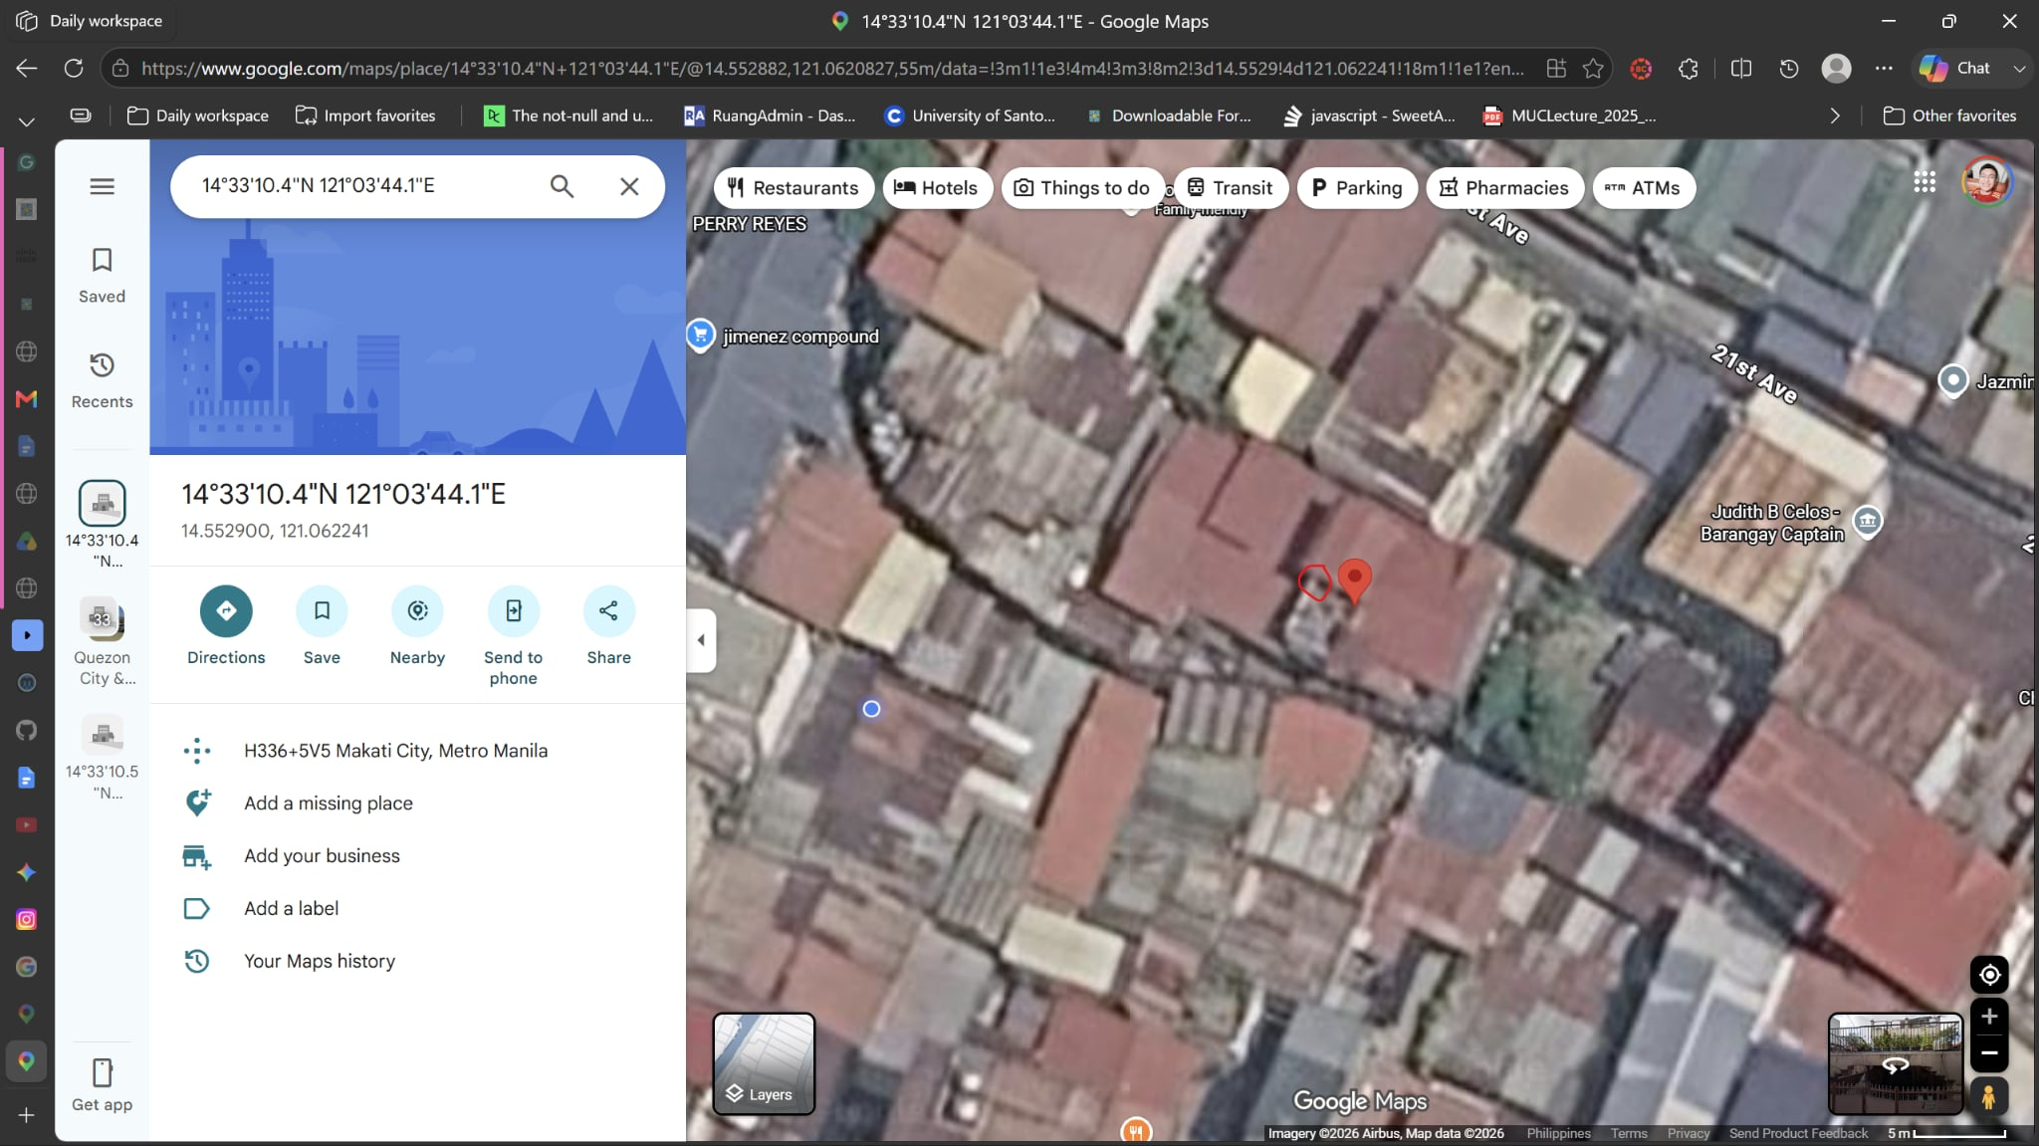
Impression: More accurate, slightly off by 1 to 2 meters

No roof obstruction:
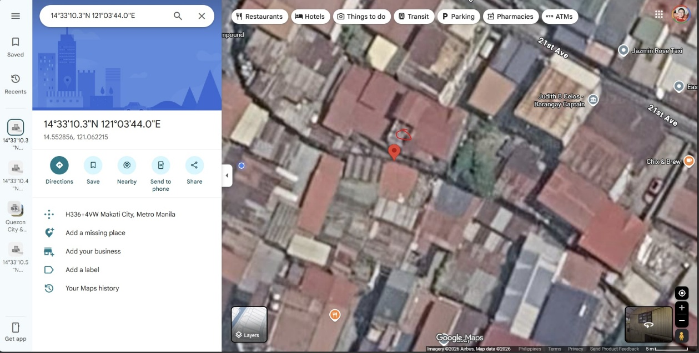
Impression: Slightly off by 1 to 2 meters.

NOTE: GPS without obstruction might be super accurate and it is possible that the Google Maps image is inaccurate because they turned the 3D bird’s eye view into a 2D image which might make the GPS result look inaccurate.

